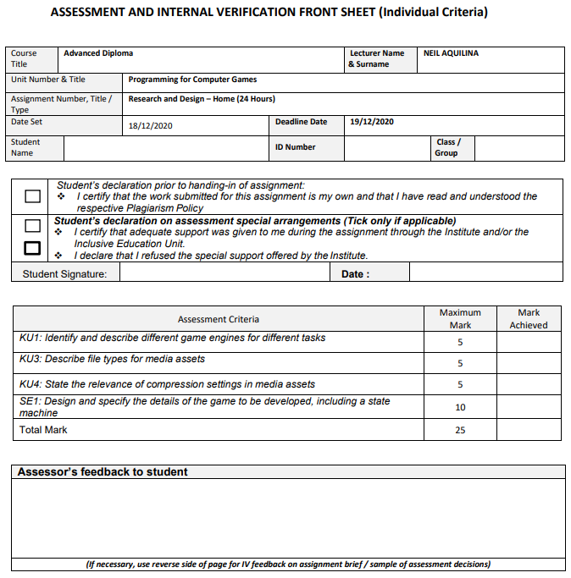

12/18/2020

266701L Sawyer

4.2B

Matthew Sawyer

Task 1: Game Engines (KU1) – 5 marks:

Research 5 Game Engines. In point form, and in your own words, for each engine list:

• The Programming Language(s) used in it

• A game programmed using that Engine

• Whether it is a 2D/3D (or both) Engine

1. Unity:

* The programming language used to program Unity is C#.
* Tyranny is a game that uses the Unity engine.
* Unity features both a 2D and 3D engine.

1. Unreal engine:

* The programming language used to program Unreal engine is C++.
* Paragon is a game that uses the Unreal engine.
* Unreal engine features both a 2D and 3D engine.

1. Frostbite:
   * The programming languages used to program Frostbite are C++, C#, IronPython, and Lua.
   * Battlefield is a game that uses the Unity engine.
   * Forstbite features only a 3D engine.
2. REDengine 4:

* The programming language used to program REDengine 4 engine is C++.
* Cyberpunk is a game that uses the REDengine 4 engine.
* REDengine 4 features only a 3D engine.

1. Creation Engine:

* The programming language used to program Creation engine is Papyrus.
* Skyrim is a game that uses the Creation engine.
* Creation engine features only a 3D engine.

Task 2: File types for media assets (KU3) – 5marks:

a. Choose 3 types of image formats from SVG, JPG, PNG, WEBP, GIF, BMP and explain each image format, in your own words.

b. Choose 2 types of audio formats from OGG, MP3, WAV, AAC, WMA and explain each format, in your own words.

a1. JPG – This image format stands for ‘Joint Photographic Group’ and is a raster format. JPG images are smaller, however, to achieve this they sacrifice the quality of the image through compression so that it is as small as possible.

a2. PNG – Portable Network Graphic is almost the same as JPG, however PNG supports 256 levels of transparency, while JPG support none. This means that with PNG you are able to save opaque images.

a3. GIF – Graphics Interchange Format are limited to a color palette of 256 and they use an 8-bitt color file which means they are ideal for saving images in greyscale.

b1. MP3 – It compressed the sound file to 1/12th the original size whilst also keeping the sound quality the same.

b2. WAV – Waveform audio file format was developed by Microsoft and is the save format for raw and uncompressed video.

Task 3: Compression in multimedia (KU4) – 5 marks:

Research the following in your own words:

a. The importance of compression in images (100 words)

b. Explain in detail using diagrams how compression in an audio file works. The diagram must be originally drawn by yourself, and not copied and pasted.

a. The main importance of compression is its use in making image files smaller, depending on the file type you can make the image file as small as you want without sacrificing any image quality, however there are some file types that compress an image even smaller than previous by sacrificing some of the quality. Since compression makes the files smaller, that means that devices, websites, applications, etc. are able to load the images faster, and in the case of websites, display the images without using too much bandwidth.

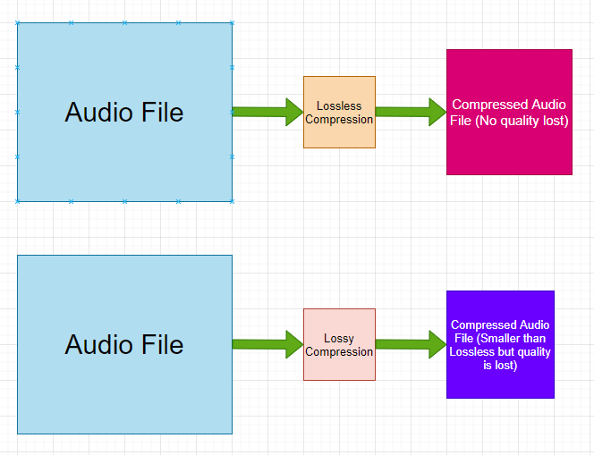b.